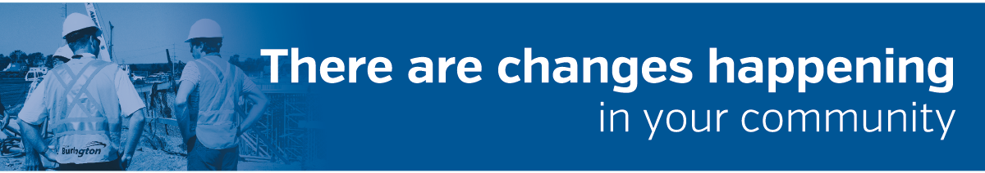 Park Avenue Area Reconstruction Project
Project Update – March 2026
Burlington.ca/ParkAvenue
The continuation of the project works in the Park Avenue area are scheduled to begin in the next couple of weeks. The residents should expect to see the Contractor mobilizing in preparation for in-road works the week of March 9th, 2026. The project is currently scheduled to be completed by Fall 2026.
Project Location
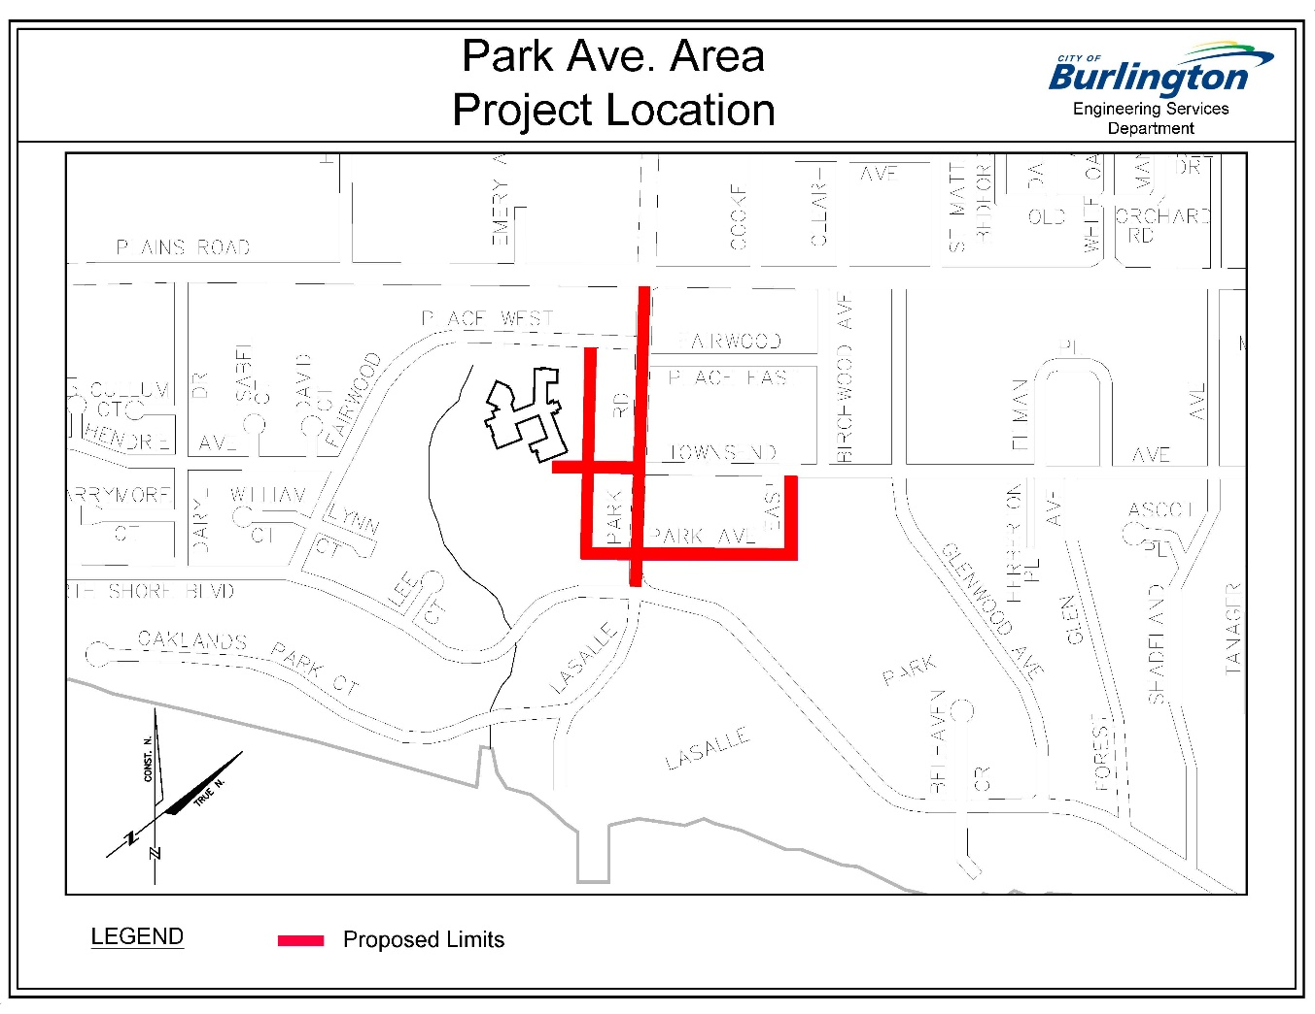

Project Schedule
The tentative construction timeline is as follows:
Location | Works | Timeline
Park Avenue West | Remaining wastewater replacement  Watermain replacement | Spring 2026
Park Avenue West | Storm sewer installation  Road works - curbs, sidewalks, asphalt, etc. | Summer 2026
Park Avenue East | Watermain replacement | Spring 2026
Park Avenue East | Storm sewer installation  Road works - curbs, sidewalks, asphalt paving | Spring/Summer 2026
Aldershot Place | Top asphalt | Summer 2026
All Streets | Street lighting upgrades | Summer 2026
Project Contacts

Visit the project webpage for contact information.
Driveways

For information regarding driveway restoration credits in-lieu of the partial driveway restoration, i.e. up to the limit of disturbance only, being completed under the contract, please contact Hasan.Rabby@burlington.ca.

Parking
For the duration of construction, enforcement of the “5-hour” maximum on-street parking by-law will be relaxed when your driveway is inaccessible or closed. Residents are asked to register their vehicle online at www.burlington.ca/parking or call 905-335-7816 Monday to Friday 8:30 to 4:30 p.m.
Vehicles are not permitted to park where signs are posted. (e.g. No Parking, No Stopping, and Fire Route etc.) In addition, vehicles are not to block fire hydrants, driveway access or park their vehicles facing the wrong direction.
How does a parking exemption work?
- It allows a vehicle to park on the street beyond the five-hour limit or overnight between 1 a.m. and 6 a.m., up to 15 days per calendar year, per licence plate.
- The only two parking offences waived AFTER a vehicle is registered for a parking exemption are:
1. Park exceeding five-hour limit
2. Park between 1 a.m. and 6 a.m.
- All other parking offences apply as they are not part of the parking exemption program.
During City construction projects, the extra days will not be included in the 15-day-per-year limit when your driveway is not accessible. However, it is important to register your vehicle for this program so that you will not receive a parking ticket.
Project Updates and Current Information
If you would like to receive notification via email when future Project Updates are available, please subscribe to the project webpage Burlington.ca/ParkAvenue
We would like to thank you for your co-operation and understanding during this construction
period.
Kind Regards,
Ryan Stoneman
Ryan Stoneman
Project Manager
City of Burlington
c.c. | Councillor Kelvin Galbraith, Ward 1
 | City of Burlington: | Janine Yaromich, Roads, Parks, and Forestry Dept., Transportation Dept.
 | Halton Region: | Fadi Yousri, Muhit Tanveer
 | King Paving and Construction Ltd.
 | Canada Post, HDSB, Halton Bus

